MICE IBE BOOKING STEPS

- MICE Offer Log In page
http://www.cathaypacific.com/cpa/en_INTL/offerspromotions/micelogin?cm_mmc=MICE-HK-_-MICE540_-CXHP-_-XX

  - Log in with your Marco Polo Club or Asia Miles member information

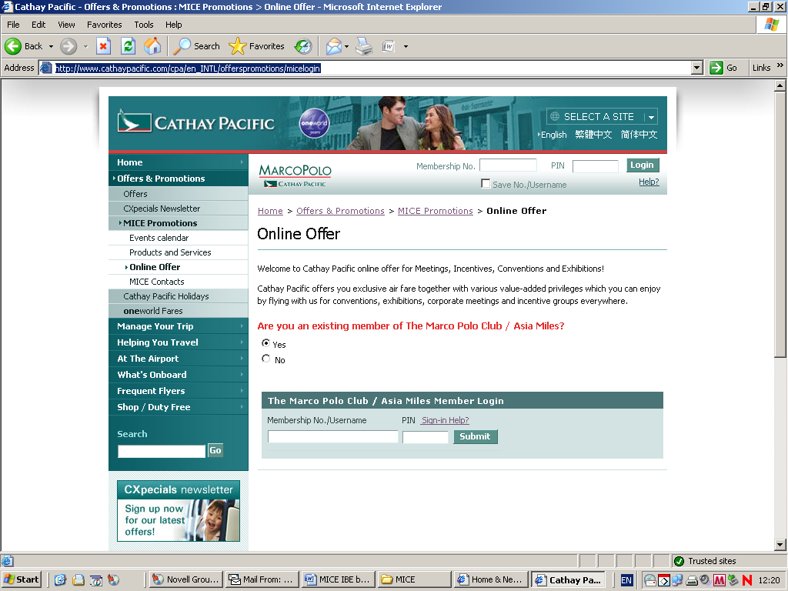
If you are a member, type in your Marco Polo Club or Asia Miles member info.

  - After you login – Event Summary
List of Registered Events
New Registration - type in MICE code (MICE540) and choose Country of Departure to register new events.

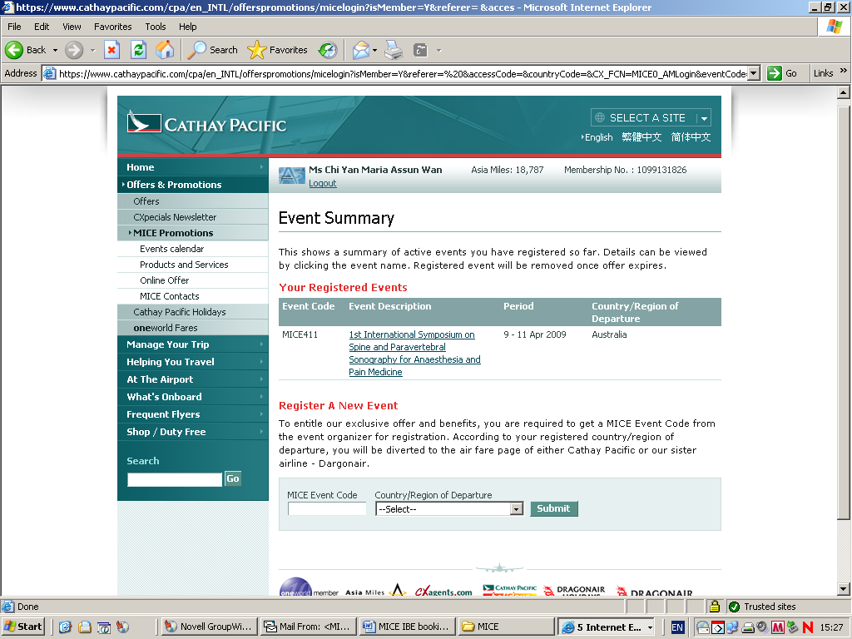
Pre-registered event - Click here to go to Step 6 directly
Type here for new register events, afterwards, will be directed to Step 6.
1.3 Click NO if you are not (not yet) a Marco Polo Club or Asia Miles member
or if this is your 2nd time login.

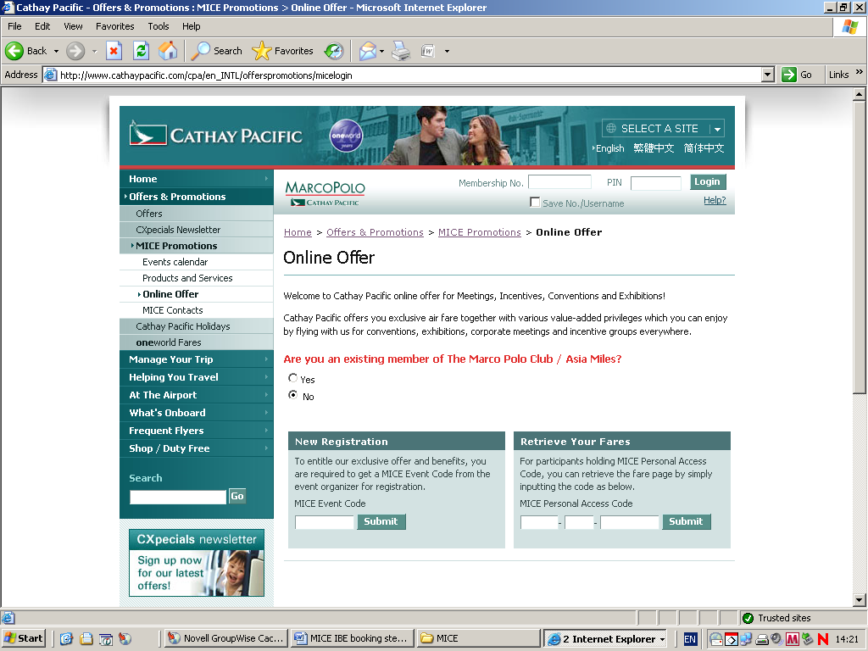
First time user, please type in MICE Event Code MICE540 here.
2nd time login – retrieve your information by inputting MICE Personal Access Code, which would be send to your email after 1st time registration.

Go to Step 2.

Go to Step 6.

- New Registration
Join Asia Miles, Asia’s leading travel reward programme for free!

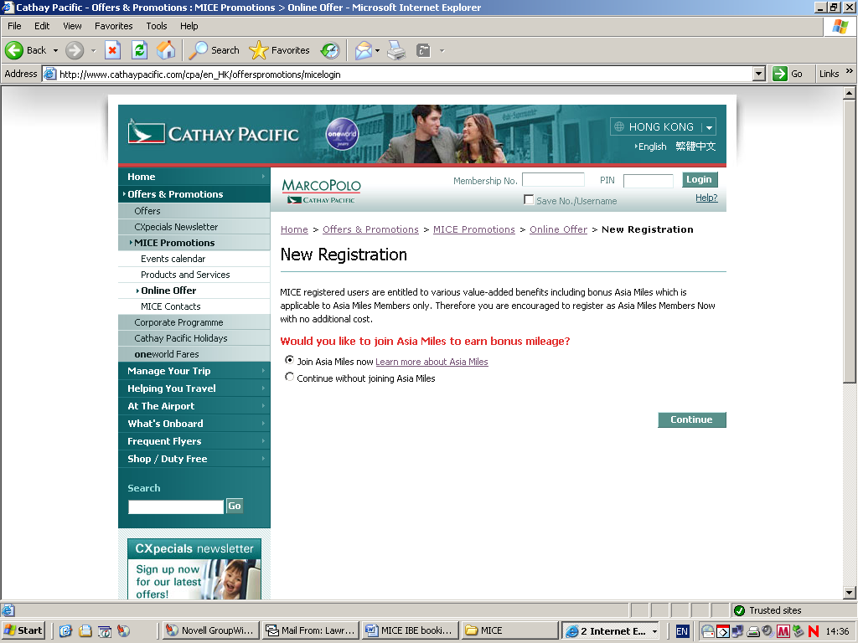
Click this box, then Continue if you want to join Asia Miles now! (see Step 3)

Go to Step 4 if you want to join Asia Miles later.
3. Asia Miles Registration

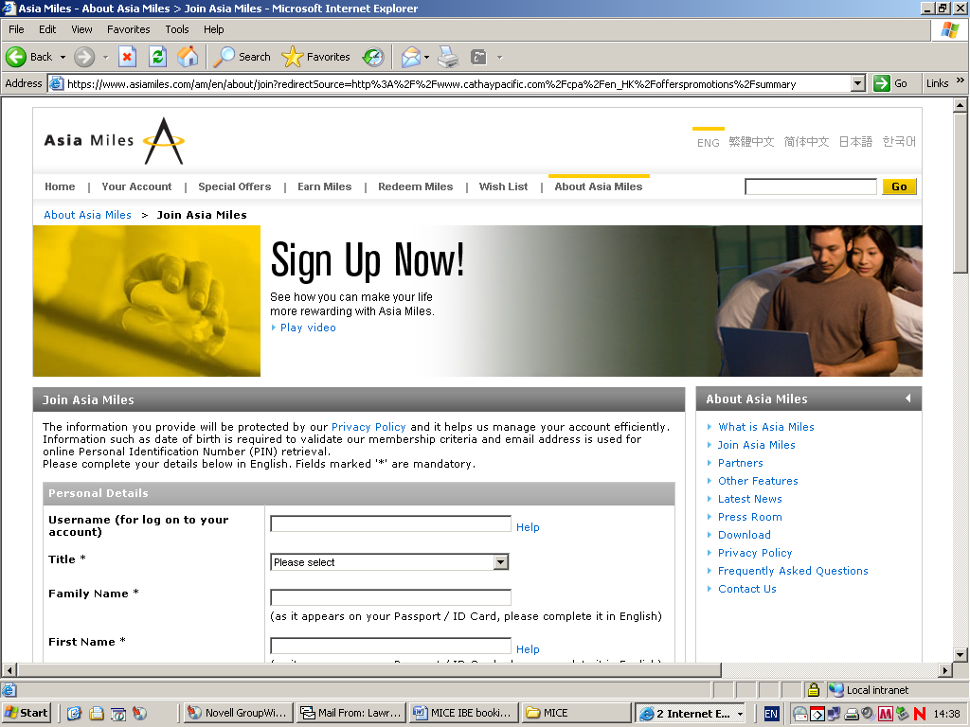

Go back to Mice login page http://www.cathaypacific.com/cpa/en_INTL/offerspromotions/micelogin?cm_mmc=MICE-HK-_-MICE540-_-CXHP-_-XX and type in Asia Miles membership number and password after signing up.

- MICE Offer Registration Form

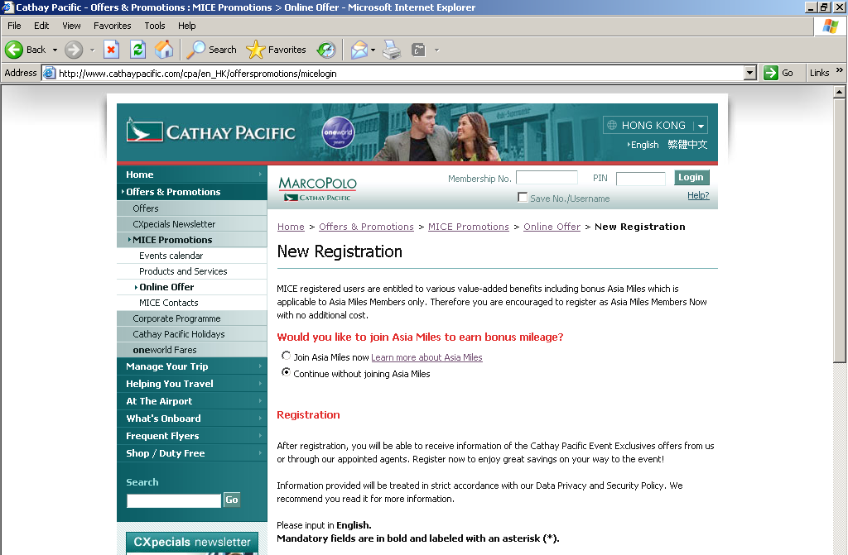
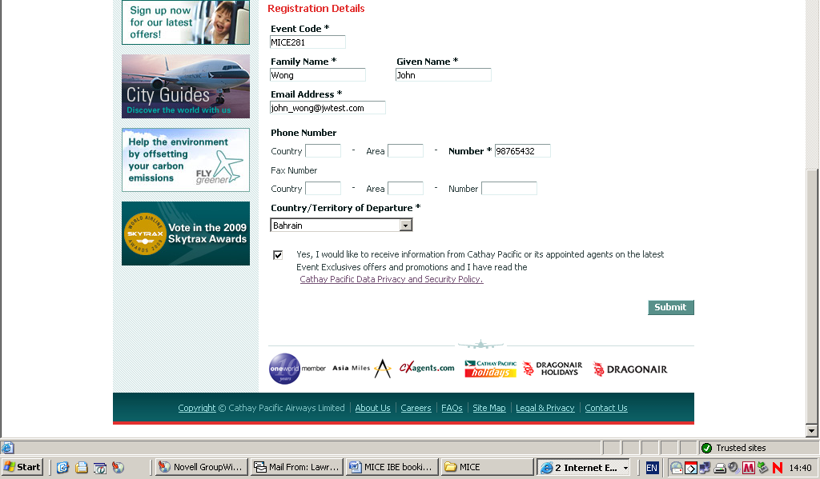
Mandatory Fields - must complete these information before proceed.

- A 10 digit personal access code will also be generated; you may use it to log-in the exclusive fares page and retrieve the fares when you re-visit the fare page again. This access code will also be sent to your registered e-mail for your record.

5.1 Click ‘Book Now’ to access the fares page and book your flights OR

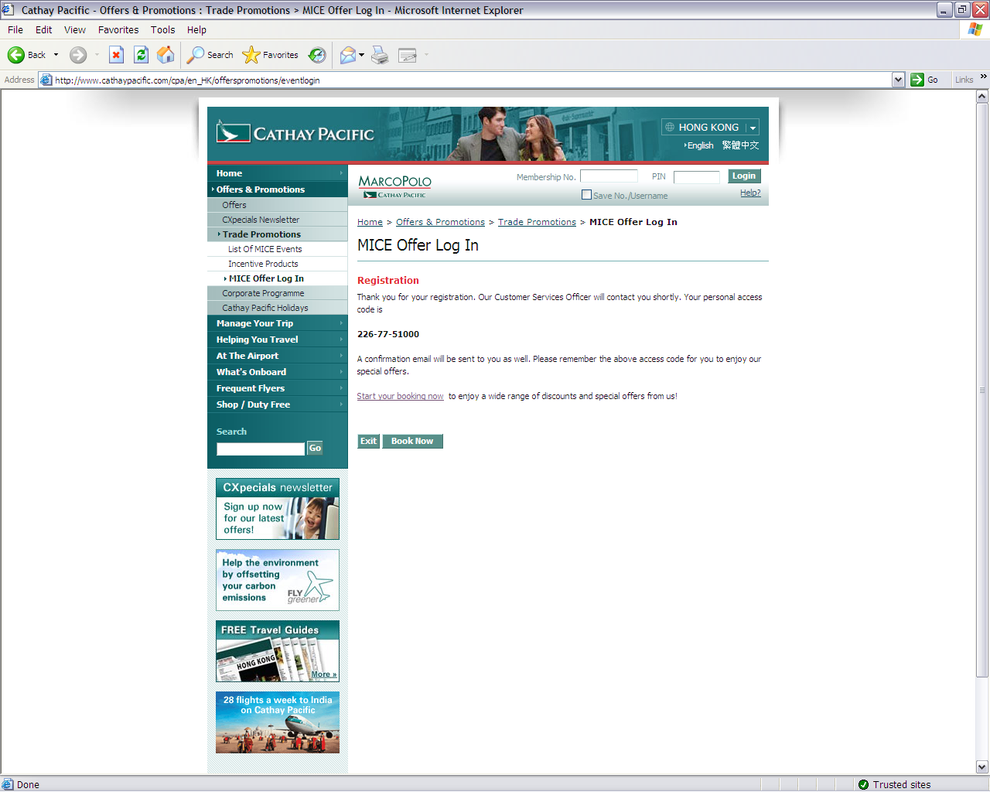

  - Click EXIT to book later.
A email will be sent to your registered email address after successful registration.
226-77-51000

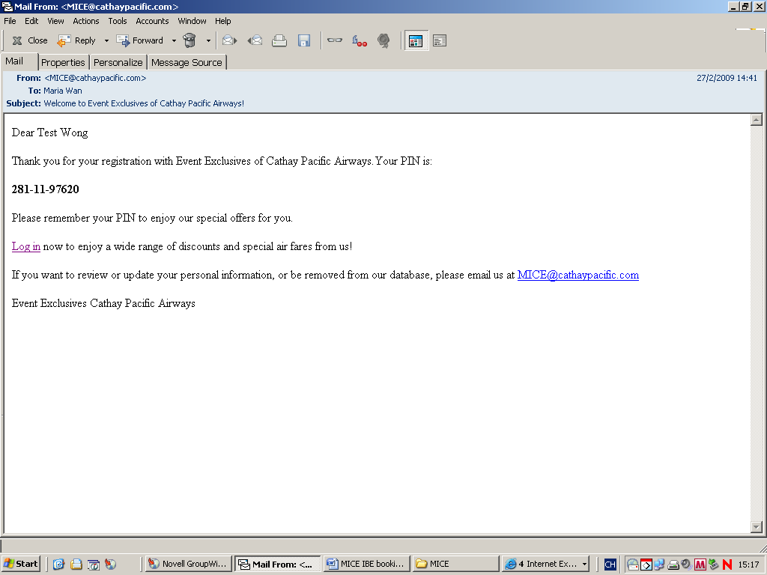

5.3 Alternative MICE Offer Log In page acknowledge message

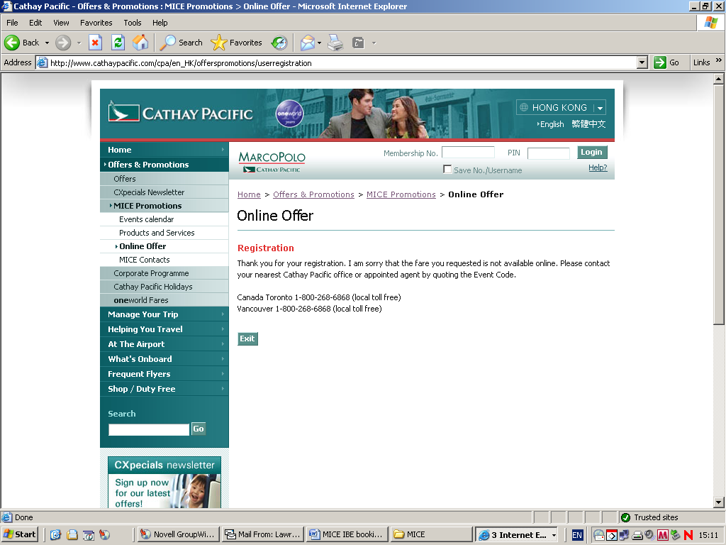

Cathay Pacific’s Customer Services Officer will contact you if the fares are not available from country of departure such as Canada, India or those countries are not on the list provided by event organizer.

Alternatively, you may contact Cathay Pacific’s local office and please remember to quote the event code MICE540.

- When you continue with “Book Now”
Event exclusive fares page

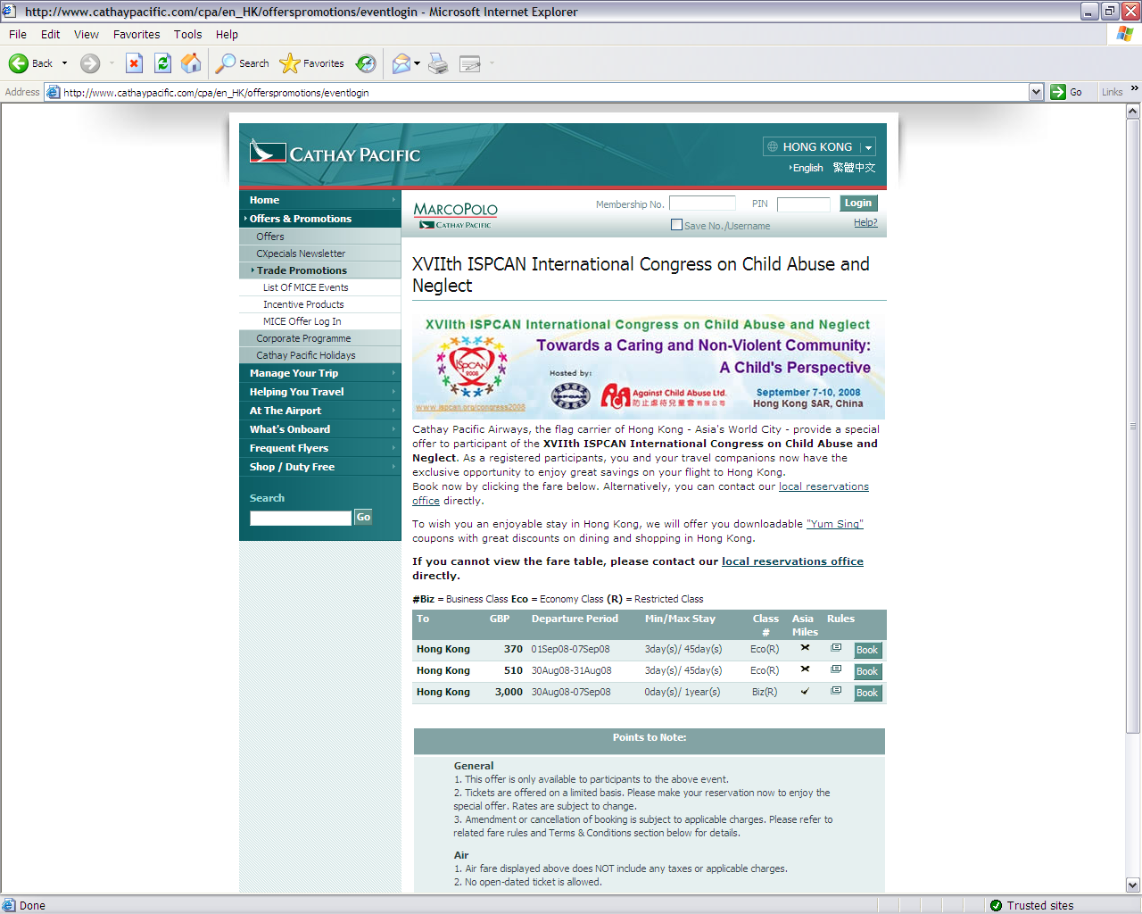

Choose the city of departure if applicable (e.g. LAX/SFO of US), compartment class and click ‘Book’ to proceed.

7. Online booking form

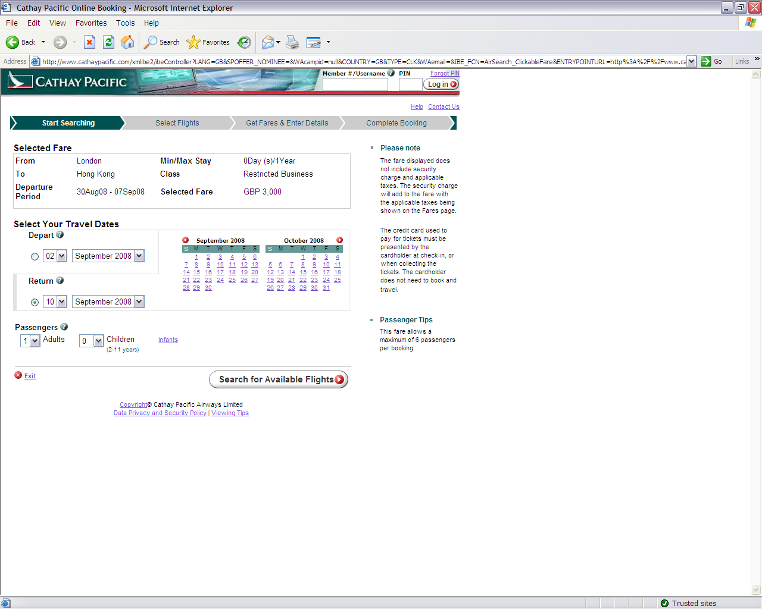

Select the departure date (fare is valid from 9 days before the event start date to the last event date), return date (ticket validity is subject to the fare conditions of fare selected) and number of passengers. Then click ‘Search for Available Flights’ to continue booking.

8. Online booking form

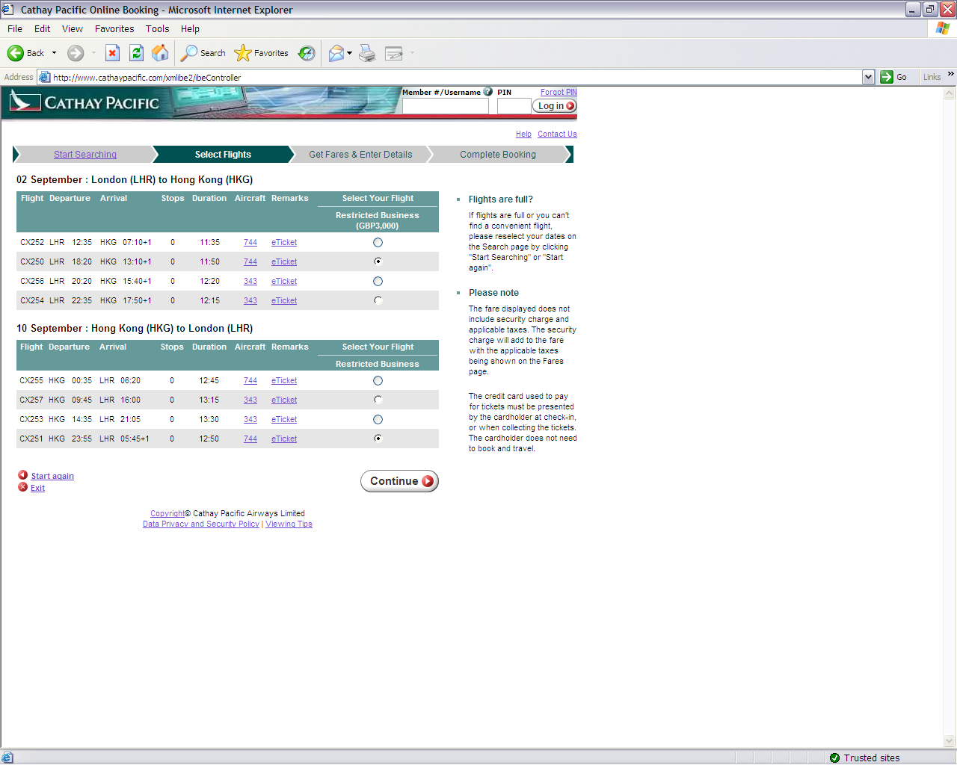

Select your preferred flights and click ‘Continue’

9. Marco Polo / Asia Miles member log in page

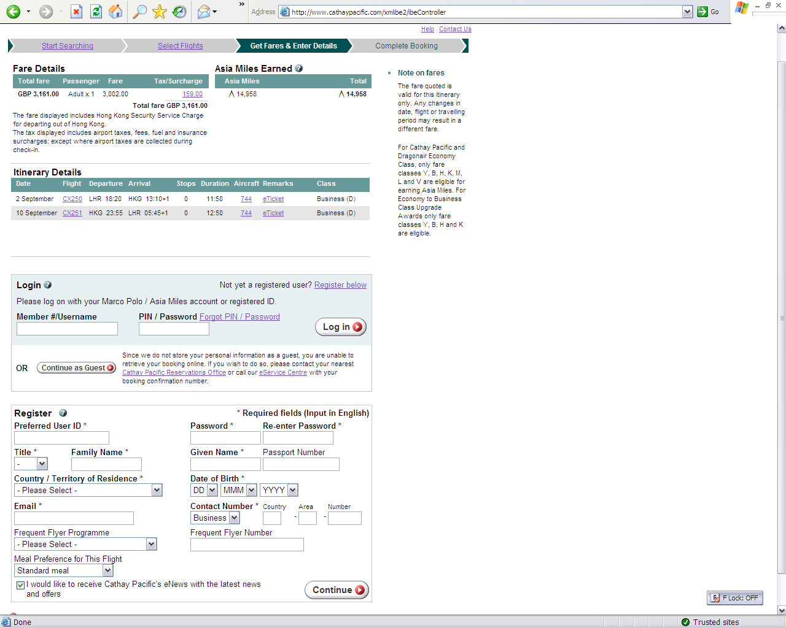
1
2
3

- You may log-in your Marco Polo / Asia Miles account to proceed

Or

- Register as Asia Miles member now

Or

- Continue as Guest

(Marco Polo / Asia Miles members are eligible to ‘On-line check-in’)

10. Part 1 - Enter Passenger Details

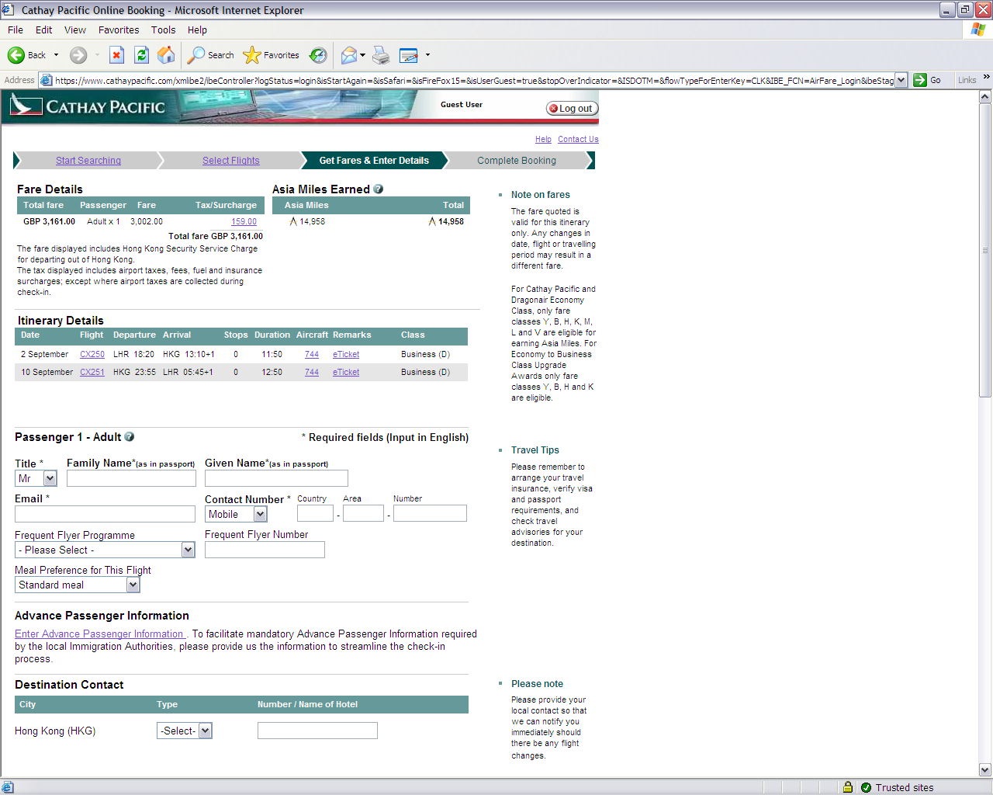

Enter passenger’s name (same as in passport).
Please make sure to provide your local contact so that CX can notify you immediately should there be any flight changes.

11. Part 2 - Enter Credit Card Details

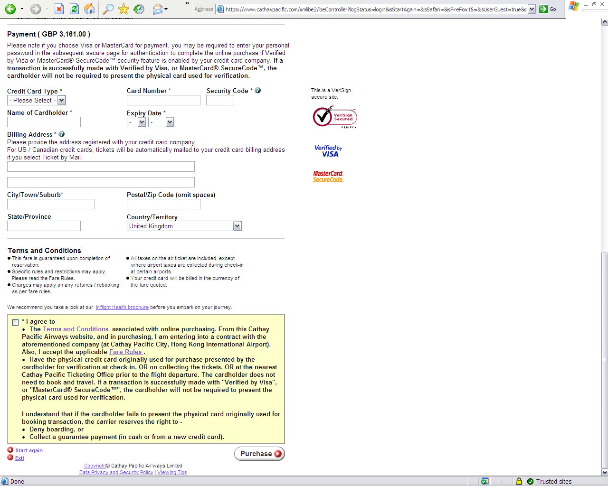

Enter your credit card information, accept the Terms and Conditions and click ‘Purchase’ to complete the transaction.

Support – eServices Centre

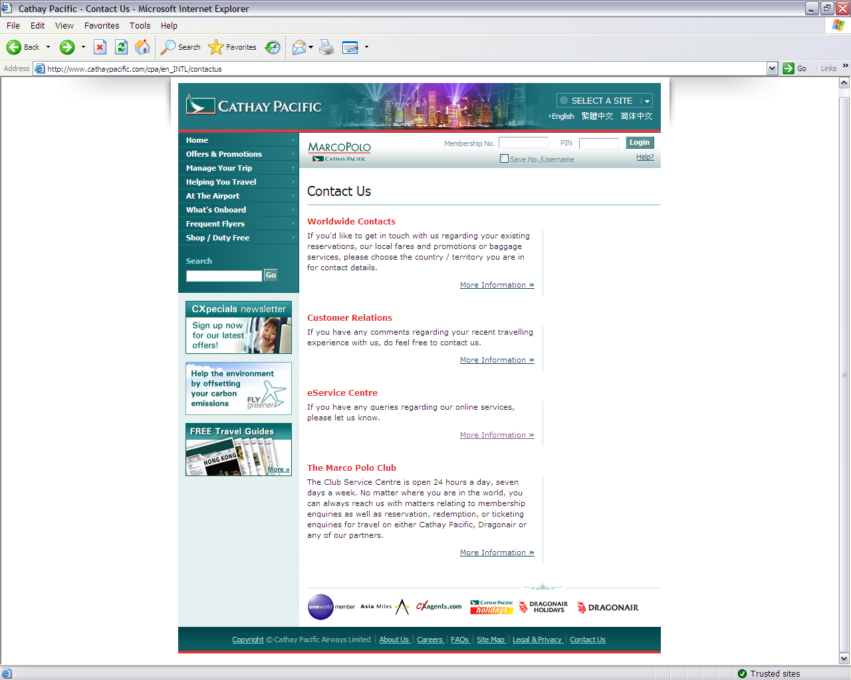

For any queries regarding our online services, please contact our eService Centre.

Support – eServices Centre

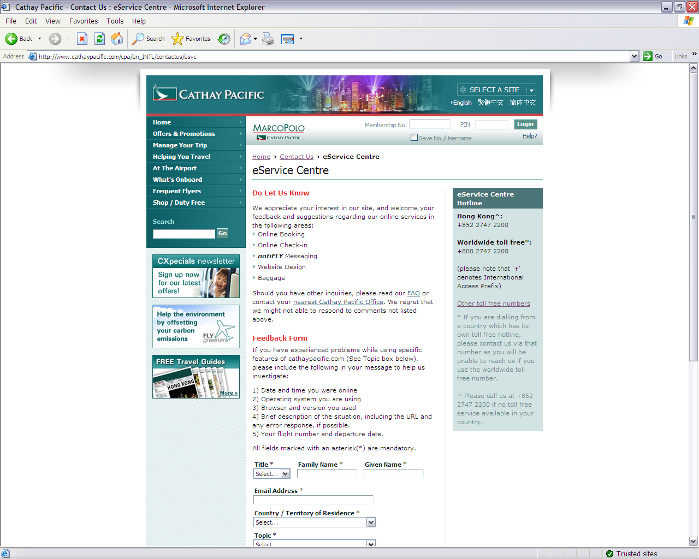

Support – CX Reservations office

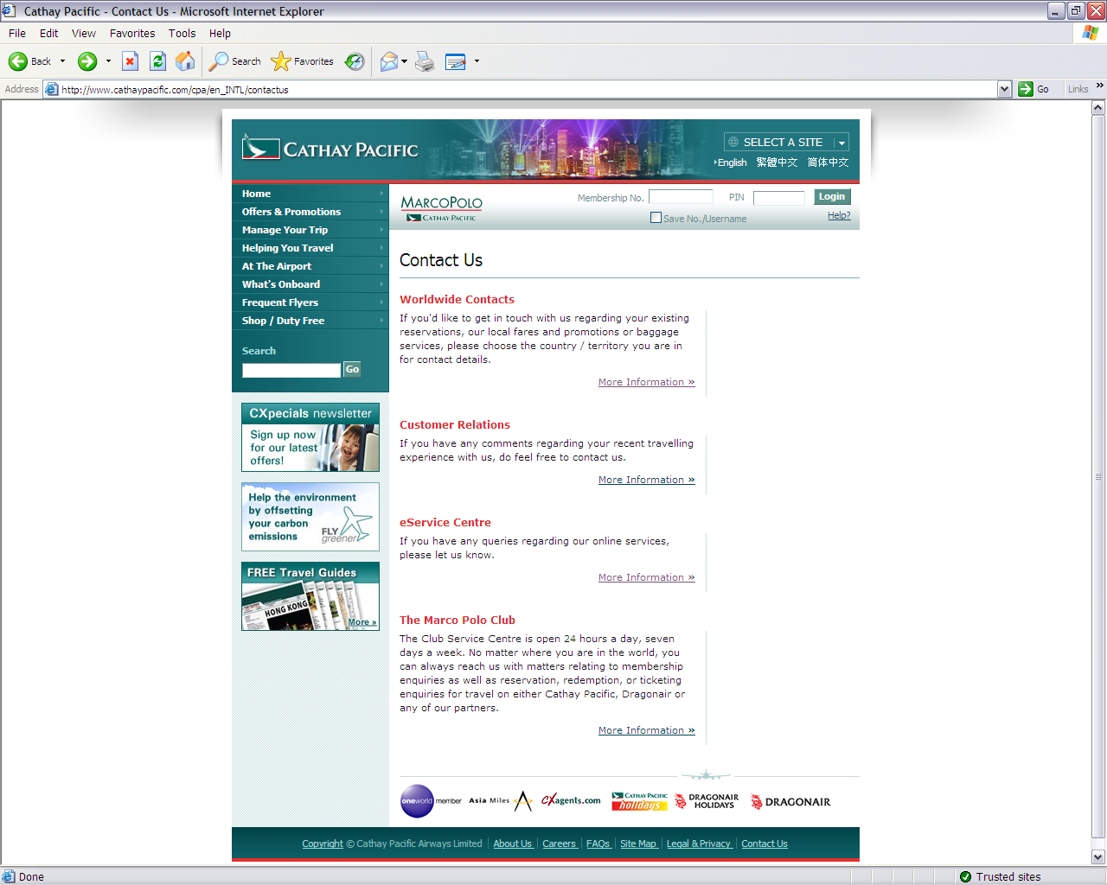

Alternatively, you may contact our reservations office.

Support – CX Reservations office

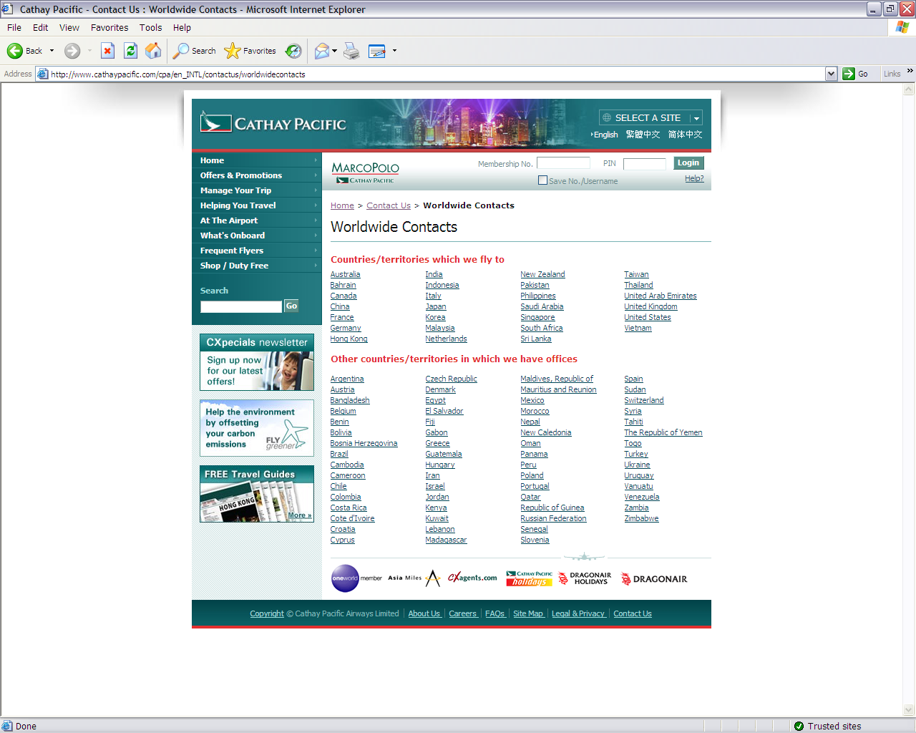

Support – CX Reservations office



